
Level Design Document: Boomer Alley
Left 4 Dead 2
Version 1.0

Designer: | Matt Duncan
Document Date: | 8/17/2012
Intended Level Delivery Date: | 11/9/2012

Document Revisions Table
Version | Description | Requestor | Date
1.0 | Initial Document | Professor Skinner | 8/17/2012

Table of Contents
Table of Contents 3
Table of Figures 5
Quick Summary 6
Hook 6
Gameplay Highlights 6
Setting Summary 6
Mission Difficulty 6
Mission Metrics 6
Characters 7
Visual Themes 7
Key Theme References 8
Level Summary 10
Campaign 10
Context 10
Backstory 10
Aftermath 10
Objective(s) 10
Overview Map 11
Level Flow 11
Flow Summary 11
Level Progression Chart 12
Level Details 13
Gameplay Area Breakdown Map 13
Detailed Walkthrough 14
Area 1: Apartment Complex 14
Initial Loadout 15
Gameplay/Story 15
Text and Dialog 15
Visual References 16
Area 2: Streets 17
Gameplay/Story 18
Text and Dialog 18
Visual References 18
Area 3: Businesses / Apartments 19
Gameplay/Story 20
Text and Dialog 20
Visual References 20
Area 4: Courtyard 21
Gameplay/Story 21
Text and Dialog 21
Visual References 22
Critical Asset List 23
References 25

Table of Figures

Figure 1 - Apartment references 8
Figure 2 - Courtyard references 8
Figure 3 - Street references 9
Figure 4 - Business references 9
Figure 5: Overview Map 11
Figure 6 - Level Progression Chart 12
Figure 7: Area Breakdown Map 13
Figure 8: Area 1 Detail Map with Key 14
Figure 9 - Left to Right: Ellis, Rochelle, Nick, Coach, Common Infected, and Boomer 16
Figure 10 - Image on the left references the courtyard, all others source images for the apartments 16
Figure 11 - Area 2 Detail Map with Key 17
Figure 12 - Streets and sidewalks similar to how they will appear in-game 18
Figure 13 - Area 3 Detail Map with Key 19
Figure 14 - Abandoned stores, courtyards, and apartments 20
Figure 15 - Area 4 Detail Map with Key 21
Figure 16 - Courtyard and apartment shots, mostly empty... imagine these with zombies 22

Level Abstract

Quick Summary
Boomers cause mayhem on “Boomer Alley", a stand-alone level for Left for Dead 2. Set in planned urban community, “Boomer Alley” features a modified Director AI. The only specials that spawn are Boomers, but both how fast they spawn and how many Infected they attract depends on the Survivors progress. Infected numbers build up as players progress. Survivors relieve the pressure by killing Boomers. If the Infected population builds too high, a mini-horde attacks. This level focuses on adjusting the relative difficulty by modifying the Director AI over time.

Hook
Similar to the sugar factory in “Hard Rain”, “Boomer Alley” focuses on one particular type of Special Infected: the Boomer. The lack of other Specials makes “Boomer Alley” memorable as “the Boomer level”.

Gameplay Highlights
“Boomer Alley” features a twist on classic Left 4 Dead 2 gameplay. The number and frequency of Common Infected periodically increases, putting more pressure on the Survivors. Killing Boomers relieves this pressure. However, Boomers do not spawn fast enough to avoid an inevitable mini-horde event at one of three pre-determined locations.

Setting Summary
Theme | Urban / suburban planned community and shopping area, post-zombie apocalypse
Mood | Building tension and pressure, interspersed with temporary relief
Setting | Modern planned shopping mall / community in a growing American city
Time of Day | Afternoon
Season | Late Spring / early Summer
Weather | Cloudy

Mission Difficulty
Position | Difficulty | Reasons
Beginning | 3 | More Common Infected than standard Left 4 Dead 2, rising pressure
Middle | 5 | Survivors still have Tier 1 weapons, increasing numbers of Infected
End | 4 | Survivors have Tier 2 weapons, number of Infected peaked in the middle
Scale: 1-10 (1 is Easiest and 10 is Hardest)

Mission Metrics
Play Time | 15 – 20 minutes
Critical Path | Approx. 3,300 feet (52,800 Hammer units)
Physical Area | Approx. 300 ft. wide x 600 ft. long x 40 ft. tall (6000 x 10,000 x 500 Hammer units)

Characters
Character | Description
Coach | Coach is a P.E. teacher from Savannah, GA. He is an overweight, African American who wears a purple and gold shirt, tan slacks, and sneakers. Like all of the Survivors, his goal is to make it through each day alive.
Ellis | Ellis was a mechanic in Savannah before the zombie apocalypse. He is a shorter-than-average Caucasian male that wears a yellow shirt, blue baseball cap, and work pants. Like all of the Survivors, his goal is to make it through each day alive.
Nick | Nick is a drifter and a con man that happened to be in Savannah when the apocalypse happened. He is a Caucasian male of average build and wears a distinctive white suit. Like all of the Survivors, his goal is to make it through each day alive.
Rochelle | Rochelle was a producer at a television station before the apocalypse. She is an average African American female and wears a pink Depeche Mode t-shirt, jeans, and a studded belt. Like all of the Survivors, his goal is to make it through each day alive.
Common Infected | The Common Infected are corpses re-animated by a virus, and their only motive is to kill the Survivors. They are both male and female, and by their appearance, they come from all lifestyles.
Boomers | Boomers are Special Infected whose bodies are bloated and full of bile. They seek to vomit on the Survivors, attracting nearby Common Infected.

Visual Themes
Theme | Description
Apartments | This theme includes the hallways, utility rooms, and actual apartments in an apartment complex. Utility rooms include laundry areas and stairways. Apartments include living rooms, kitchens, bathrooms, and bedrooms. Appropriate furniture and debris litter the apartments. Damage appears in some apartments, connecting them through broken walls. Plaster and wallpaper adorn the walls, while carpet, tile, and wood make up the floors. Most apartments are unlit except through windows, and only a few emergency lights scattered in the hallways are on.
Courtyards | Courtyards are the common areas typical of apartment communities. Typically, they include some outdoor furniture, grills, and decorative plants. They also include pools. Sunlight diffused through clouds lights courtyards.
Streets | The streets are the building exteriors, storefronts, streets, and sidewalks surrounding the interior spaces. Cars litter the street. Sunlight lights the streets.
Businesses | The nearly empty interiors of businesses are often unlit except by light coming throw windows. Various shops exist such as boutiques, diners, and convenience stores.

Key Theme References

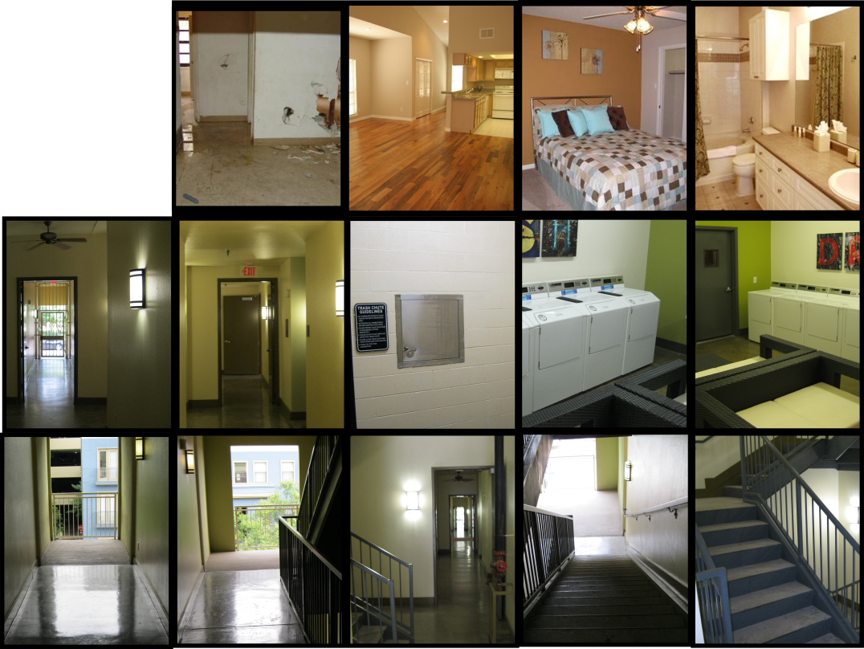
Figure 1 - Apartment references
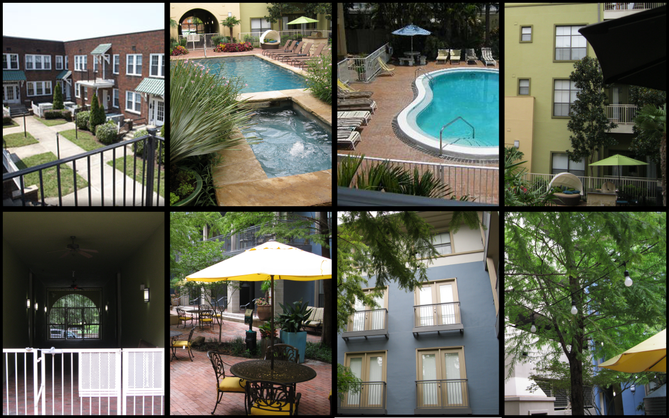
Figure 2 - Courtyard references

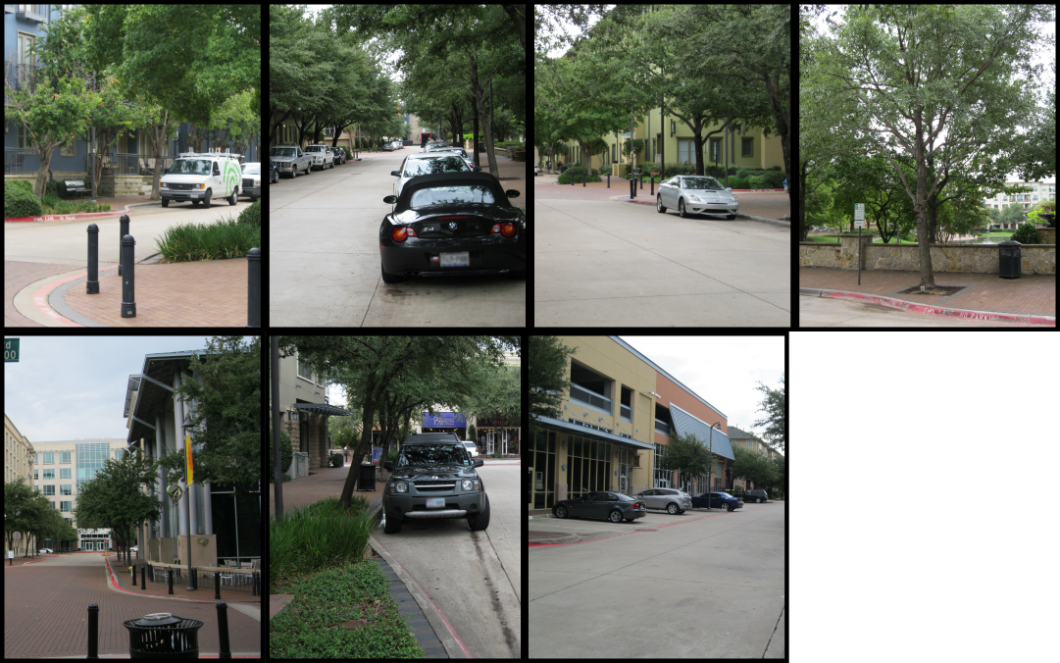
Figure 3 - Street references

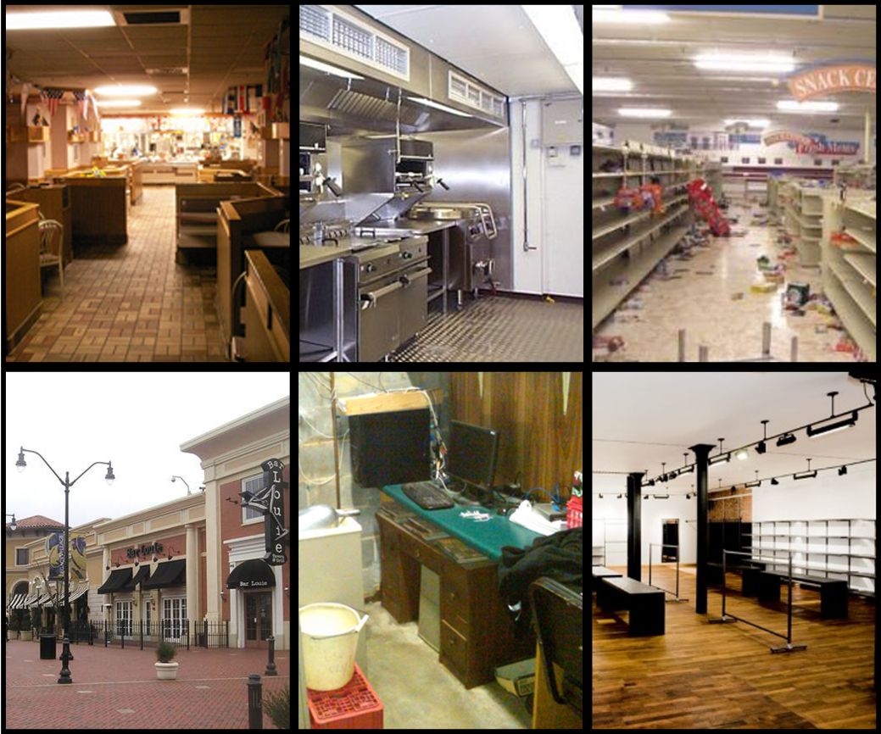
Figure 4 - Business references

Level Summary

Campaign

Context
“Boomer Alley” takes place after the events of Left 4 Dead 2. It is the first level in a four-part campaign that follows the Survivors as they escape from a planned community to a government-held sport stadium.

Backstory
After making their way through New Orleans, LA, the Survivors pressed west into Texas. There, they fought their way into the ruins of a north Texas community and decided to try to hold out in an abandoned apartment complex. Little did they know that the zombie virus combined with a local outbreak of West Nile virus to create an inordinate number of Boomers.

Aftermath
After “Boomer Alley”, the Survivors make it to the highway in “Overpass”, follow the highway to the stadium in “Roadblock”, and finally hold out in the stadium until a helicopter arrives in “End Zone”.

Objective(s)
- At least one Survivor must make it to the designated Safe House at the end of the level.
  - At least one Survivor must survive.
  - Survivors must defeat a large number of Infected to survive.
  - Survivors must avoid Boomer vomit, and defeat them from a distance if possible.
  - Survivors should collect additional items, weapons, and ammo throughout the level.

Overview Map
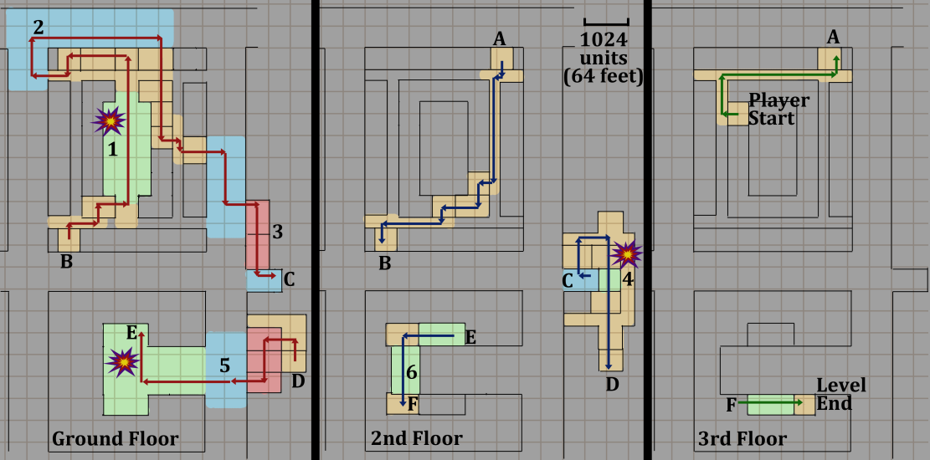

Figure 5: Overview Map

Level Flow

Flow Summary
- The Survivors make their way from the apartment and through the complex. They fight a growing number of Common Infected in the apartments and halls, making their way to the pool courtyard. In the courtyard, they potentially face a mini-horde event, where they must withstand a very large Common Infected rush (wow moment).
- The pressure continues to mount as the Survivors make their way onto the streets. They fight the Common Infected among the cars and sidewalks. Eventually they detour back through apartments to another street.
- The Survivors make their way into an abandoned diner. They make their way through the kitchen into a convenience store.
- The store’s exit leads them to a back alley, where they make their way up a fire escape into more, run-down apartments connected to a small, second floor courtyard (wow moment).
- They cross the courtyard into another apartment, then down into a boutique and out onto the streets once again.
- The large, open-air garden / courtyard of another group of apartments draws the survivors in. This area shows signs of CEDA presence, as if they were using it as a disaster relief area. The survivors make their way around the CEDA camp and up on the second and third floor terraces. Eventually they find a third floor apartment with the lights on, a safe house the level’s end.

Level Progression Chart

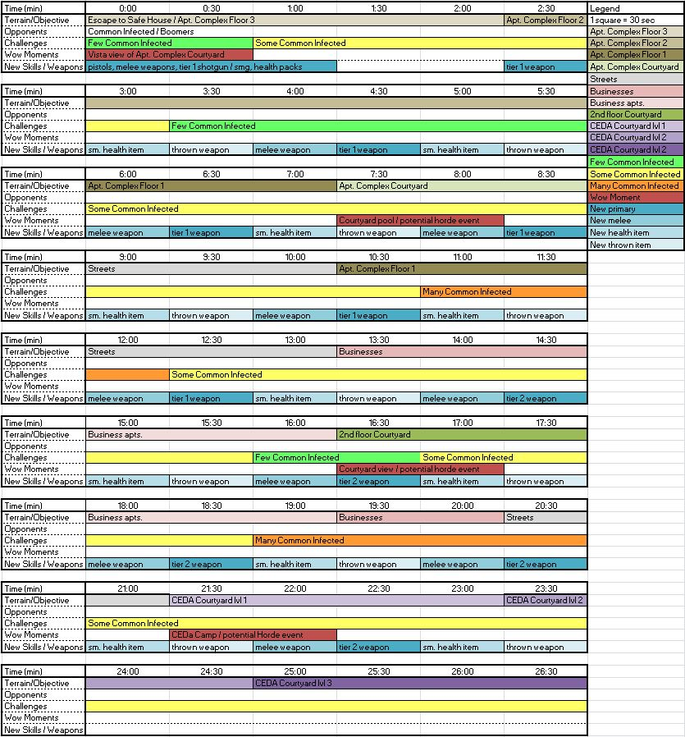
Figure 6 - Level Progression Chart
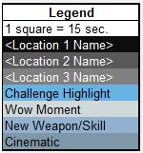

Detailed Design

Level Details

Gameplay Area Breakdown Map
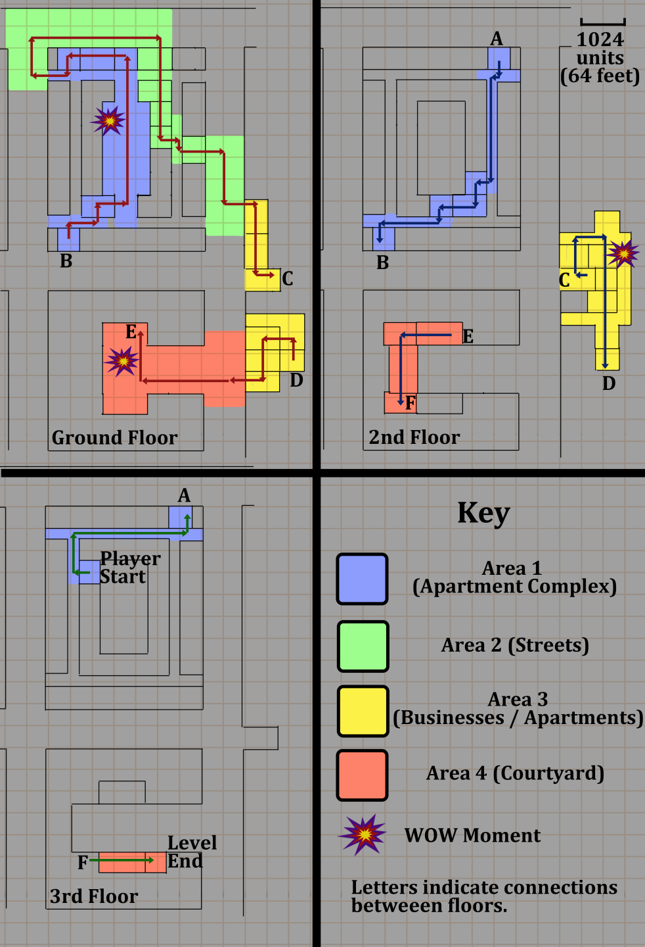
Figure 7: Area Breakdown Map

Detailed Walkthrough

Area 1: Apartment Complex
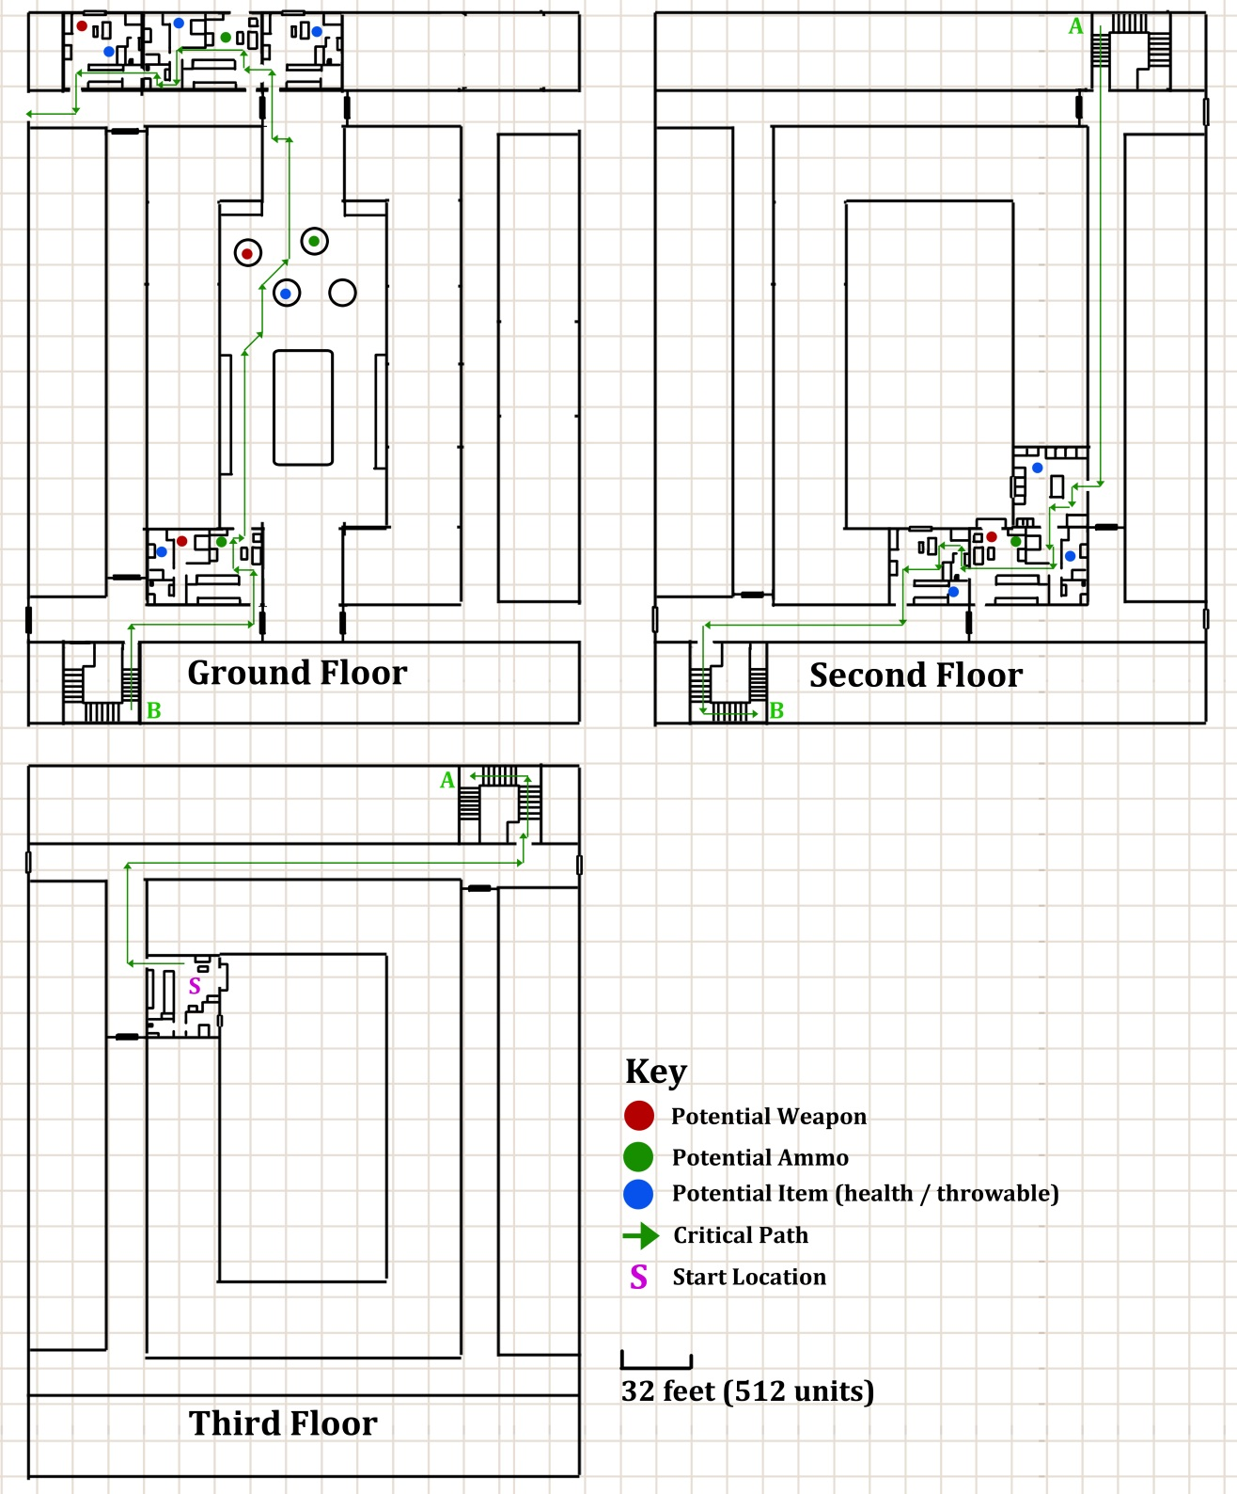
Figure 8: Area 1 Detail Map with Key

Initial Loadout
- One pistol
- Optional Melee weapon (in start area)
- Shotgun or SMG (in start area)
- Health Kit (in start area)

Gameplay/Story
- Survivors begin in the safe room, and may take their time equipping themselves.
- When the Survivors leave the safe room, they encounter Common Infected. The Director AI controls Common Infected spawn locations. These are not on the map as they could spawn anywhere out of the Survivors line of sight.
- Every 30 seconds, there is an increase in the number and aggressiveness of the Common Infected. There are five levels of aggressiveness in total.
- Boomers spawn approximately every 45 seconds along with the other Infected. This reduces to once every 30 seconds at aggressiveness level 3 and once every 15 seconds at maximum aggressiveness. Killing a boomer reduces the Common Infected aggressiveness by one level.
- If the Infected aggressiveness reaches level five before the players reach the first floor, a mini-horde event occurs in the pool area on the ground floor. This is a very large number of Common Infected that rush the players.

Text and Dialog

Objective Text
- While the Survivors are in the safe room, text pops up explaining to kill Boomers to ease the pressure.

Dialog/Script
- Only incidental automatic chatter controlled by the AI occurs.

Visual References

Theme
Apartments / Courtyard (for the pool area)

Characters/Vehicles Introduced
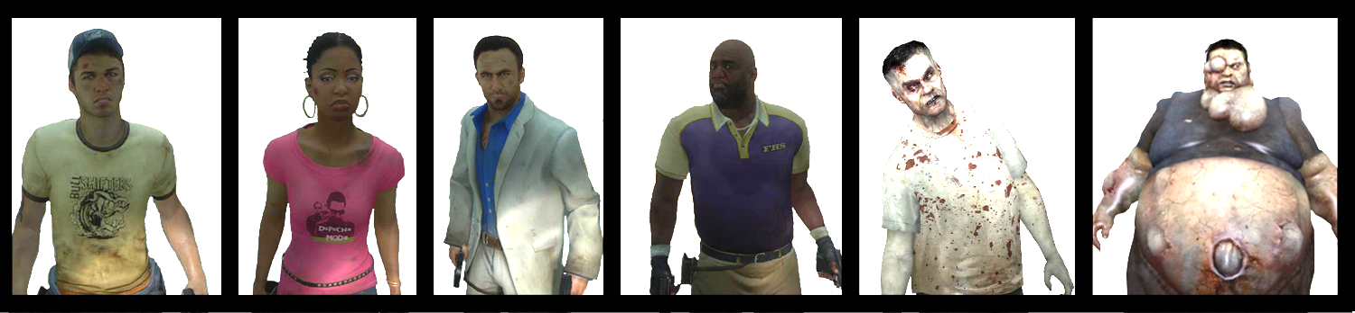
Figure 9 - Left to Right: Ellis, Rochelle, Nick, Coach, Common Infected, and Boomer

Environment References
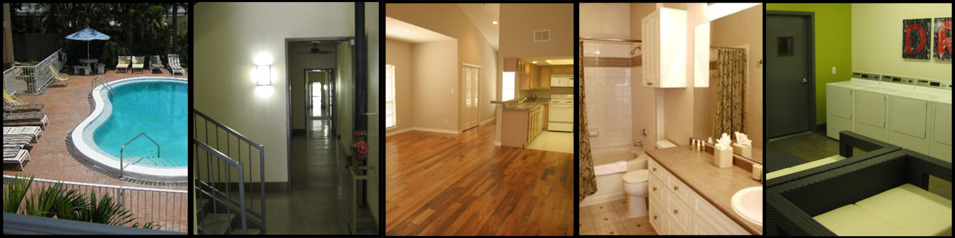
Figure 10 - Image on the left references the courtyard, all others source images for the apartments

Area 2: Streets
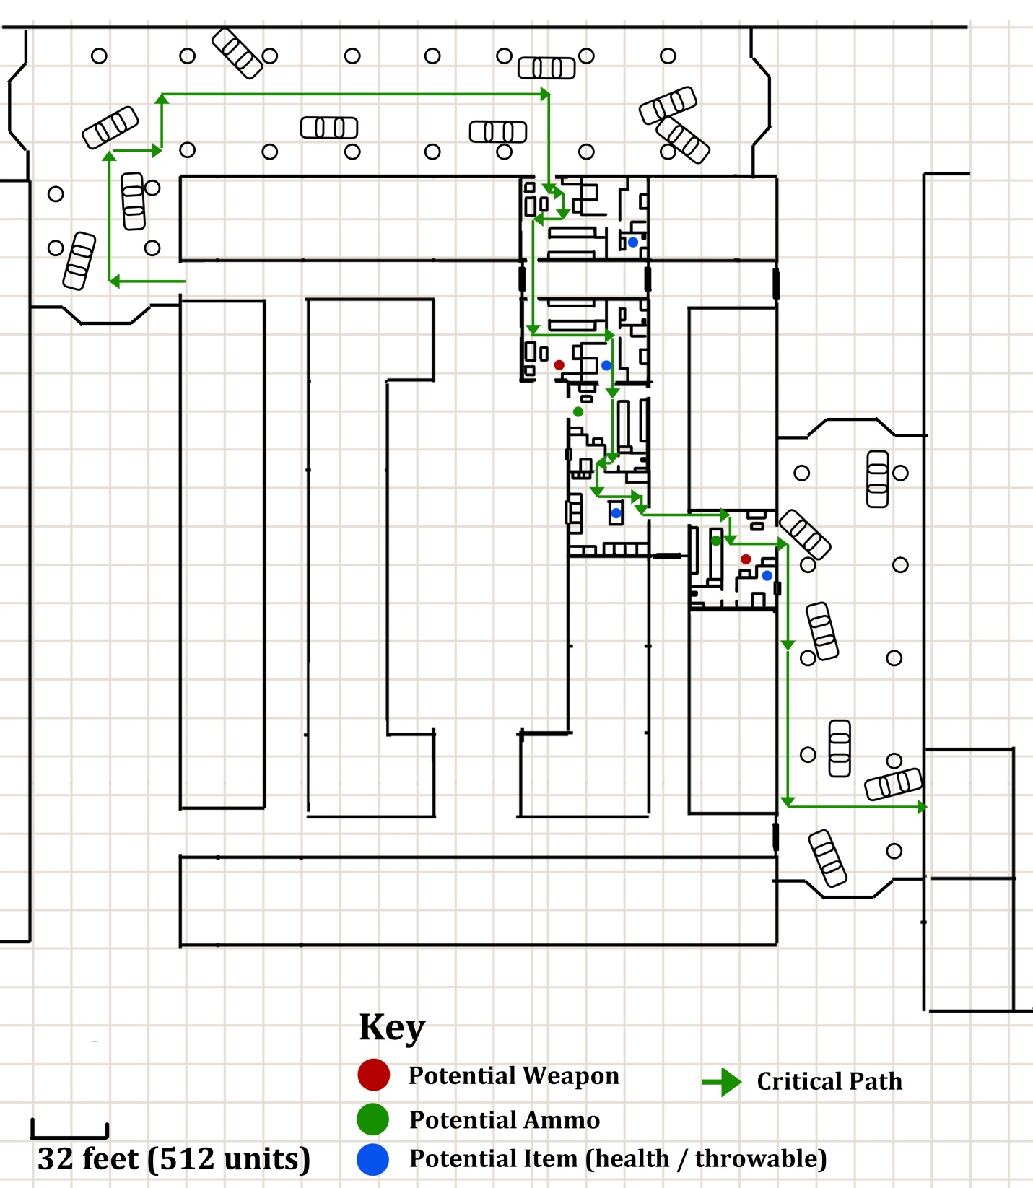
Figure 11 - Area 2 Detail Map with Key

Gameplay/Story
- The Survivors head into the streets from the apartment complex.
- The Director AI controls Common Infected spawn locations. These are not on the map as they could spawn anywhere out of the Survivors line of sight.
- Every 30 seconds, there is an increase in the number and aggressiveness of the Common Infected. There are five levels of aggressiveness in total.
- Boomers spawn approximately every 45 seconds along with the other Infected. This reduces to once every 30 seconds at aggressiveness level 3 and once every 15 seconds at maximum aggressiveness. Killing a boomer reduces the Common Infected aggressiveness by one level.
- If the Infected aggressiveness reaches level five before the players reach the next area, a mini-horde event occurs in the business area. This is a very large number of Common Infected that rush the players.

Text and Dialog

Objective Text
- N/A

Dialog
- Only incidental automatic chatter controlled by the AI occurs.

Visual References

Theme
Streets / Apartments

Characters/Vehicles Introduced
N/A

Environment References
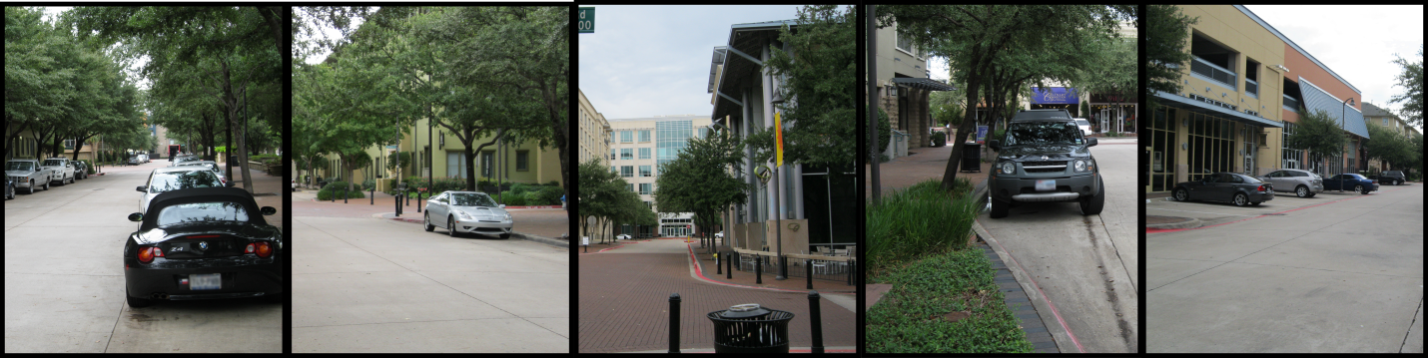
Figure 12 - Streets and sidewalks similar to how they will appear in-game

Area 3: Businesses / Apartments

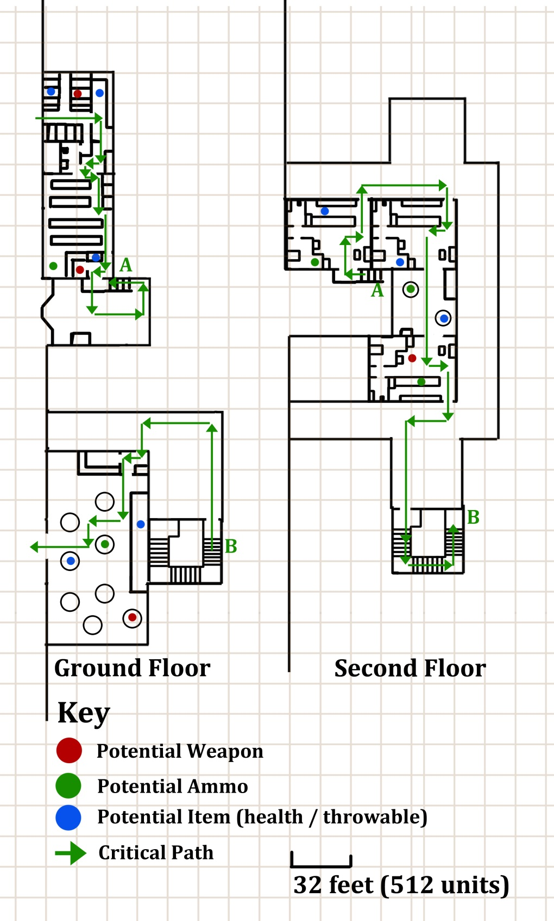
Figure 13 - Area 3 Detail Map with Key

Gameplay/Story
- The Survivors wander into a building with shops and apartments to search for supplies.
- The Director AI controls Common Infected spawn locations. These are not on the map as they could spawn anywhere out of the Survivors line of sight.
- Every 30 seconds, there is an increase in the number and aggressiveness of the Common Infected. There are five levels of aggressiveness in total.
- Boomers spawn approximately every 45 seconds along with the other Infected. This reduces to once every 30 seconds at aggressiveness level 3 and once every 15 seconds at maximum aggressiveness. Killing a boomer reduces the Common Infected aggressiveness by one level.
- If the Infected aggressiveness reaches level five before the players reach the second floor, a mini-horde event occurs on the second floor courtyard. This is a very large number of Common Infected that rush the players.

Text and Dialog

Objective Text
N/A

Dialog
- Only incidental automatic chatter controlled by the AI occurs.

Visual References

Theme
Businesses, Apartments, Courtyard

Characters/Vehicles Introduced
N/A

Environment References
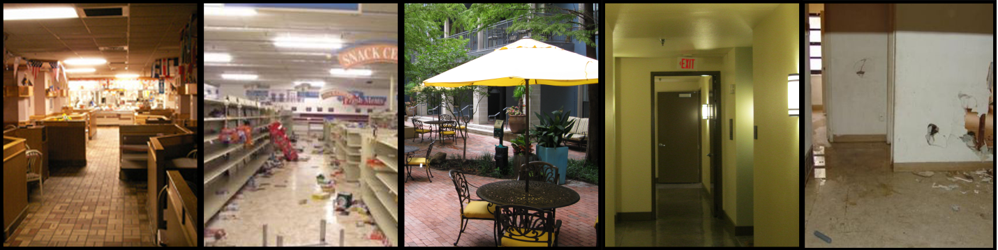
Figure 14 - Abandoned stores, courtyards, and apartments

Area 4: Courtyard
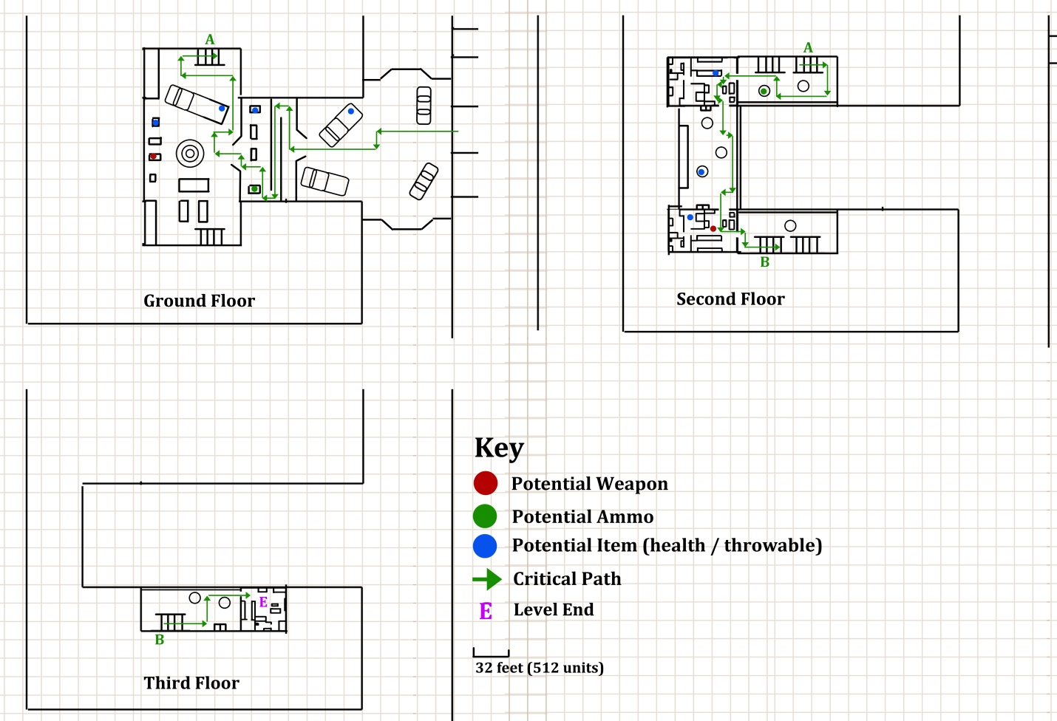
Figure 15 - Area 4 Detail Map with Key

Gameplay/Story
- The Survivors exit the shops and cross the street to a CEDA camp set up in a courtyard.
- The Director AI controls Common Infected spawn locations. These are not on the map as they could spawn anywhere out of the Survivors line of sight.
- Every 30 seconds, there is an increase in the number and aggressiveness of the Common Infected. There are five levels of aggressiveness in total.
- Boomers spawn approximately every 45 seconds along with the other Infected. This reduces to once every 30 seconds at aggressiveness level 3 and once every 15 seconds at maximum aggressiveness. Killing a boomer reduces the Common Infected aggressiveness by one level.
- If the Survivors have not triggered a mini-horde before area 4, one occurs in the courtyard. This is a very large number of Common Infected that rush the players.

Text and Dialog

Objective Text
N/A

Dialog
- Only incidental automatic chatter controlled by the AI occurs.

Visual References

Theme
Streets / Courtyards / Apartments

Characters/Vehicles Introduced
N/A

Environment References
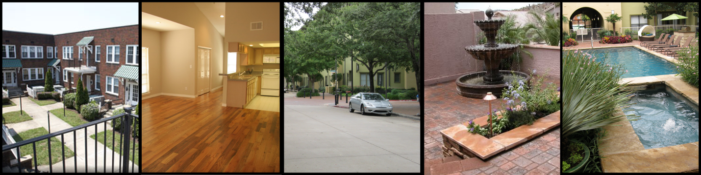
Figure 16 - Courtyard and apartment shots, mostly empty... imagine these with zombies

Critical Asset List
Asset Name | Type | Use | Exists? | Link/Pic
Couch.mdl | Static | Apartment furniture | Yes | 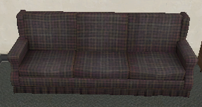
Stove01.mdl | Static | Apartment / restaurant appliance | Yes | 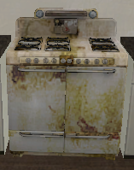
Fridge002.mdl | Static | Apartment / restaurant appliance | Yes | 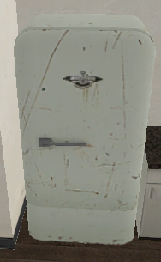
Bed.mdl | Static | Apartment furniture | Yes | 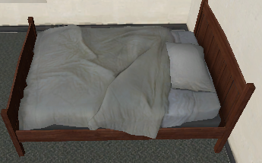
Bathtub01.mdl | Static | Apartment fixture | Yes | 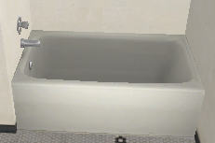
Washer.mdl | Static | Utility room appliance | Yes | 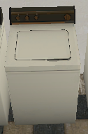
Dryer.mdl | Static | Utility room appliance | Yes | 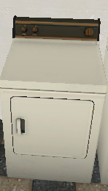
Plastic_chair001.mdl | Physics | Courtyard furniture | Yes | 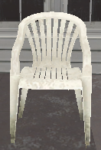
Round_table001.mdl | Static | Courtyard furniture | Yes | 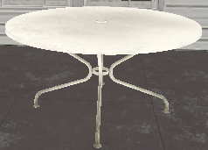
Cara_82hatcback.mdl | Static | Car in street | Yes | 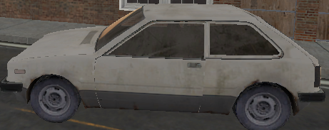
Booth01.mdl | Static | Restaurant furniture | Yes | 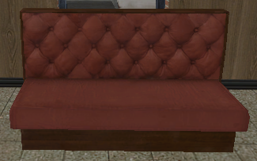
Booth_table.mdl | Static | Restaurant furniture | Yes | 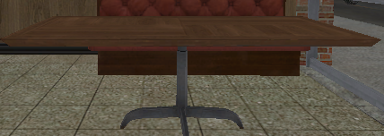
Shelvinggrocery01.mdl | Static | Convenience store furniture | Yes | 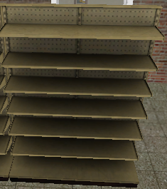
Carpet003b | Material | Flooring for apartments | Yes | 
Urban_woodfloor01 | Material | Flooring for apartments | Yes | 
Floor08 | Material | Flooring for apartments | Yes | 
Urban_plasterwall_05a_nobump | Material | Internal walls for apartments | Yes | 
Ceiling_popcorn02 | Material | Ceiling for apartments | Yes | 
Siding05 | Material | External walls for apartments | Yes | 
Urban_road_01a | Material | Road surface for streets | Yes | 
Brickwall_mill01 | Material | External walls for buildings | Yes | 
Wood_panel01a | Material | Internal walls for shops | Yes | 
Ceilingtilea | Material | Ceilings for shops | Yes | 
sky_l4d_c4m4_hdr | Material | Cloudy sky material for skybox | Yes | 
Urban_concretefloor_03b | Material | Floor material for sidewalks / courtyard | Yes | 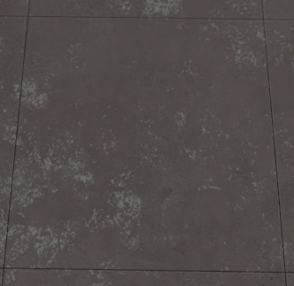

References
- http://ww1.hdnux.com/photos/05/22/26/1385892/3/628x471.jpg
- http://www.apartmentwiz.com/dallas_apartments/images/dallas_apartments_images/addison_apartments/1686_live_addison_apts_11.jpg
- http://www.apartmentwiz.com/dallas_apartments/images/dallas_apartments_images/dallas_park_central_apartments/1715_interior_bed.jpg
- http://www.execustay.com/furnished-apartments/dallas/northend/property_photos/DallasFurnishedApartmentBathroom-368x277.JPG
- http://thecoreproperties.com/wp-content/uploads/2011/01/courtyard_apartments1.jpg
- http://www.popgunchaos.com/wp-content/uploads/2011/05/p237055-Apartment_Pool6.jpg
- http://farm3.static.flickr.com/2613/3740843910_ca037787a6_o.jpg
- http://livingonstoredfoods.files.wordpress.com/2011/03/empty-shelves.jpg
- http://mobiluxe.files.wordpress.com/2010/12/empty-retail.jpg?w=604
- http://0.tqn.com/d/cleveland/1/0/y/A/-/-/legacy2.jpg
- http://www.vestedbb.com/photos/listing_photo/big/back_office.jpg
- http://www.ellaneblog.net/wp-content/uploads/2010/06/KitchenCookingArea.jpg
- http://images3.wikia.nocookie.net/__cb20090712041034/left4dead/images/thumb/e/e8/Zombie_1.png/250px-Zombie_1.png
- http://images4.wikia.nocookie.net/__cb20101024005741/left4dead/images/thumb/b/b5/Boomeridle_1.png/250px-Boomeridle_1.png
- http://s3-media3.ak.yelpcdn.com/bphoto/tSI5CA87lIs_6ewJMqF4tg/l.jpg

